ETD555 Project Report

Group Members –

Section –

Submitted to –

Contents

ABSTRACT 3

INTRODUCTION 4

Description 5

RESULTS AND DISCUSSIONS 8

Extensions 8

CONCLUSION 9

# ABSTRACT

The main goal of the project was to build and develop a circuit that is able to change the speed and direction of a 12 DC motor. It is able to interface with the LabJack UE9 using a python program code in Spyder IDE. The projects make use of certain concepts of Electrical engineering like optical isolation and H-bridge circuits. It also makes use electrical components like IC driver chips and Optical isolators. Teamwork and organization play a crucial part in the making and completion of the project.

# INTRODUCTION

In this project, a circuit has been made such that it interfaces with a PC and the LabJack UE9 to control the speed and direction of the motor. It makes use of several concepts learnt throughout the course of the ETD555 subject. It has been built on a breadboard and all the components are arranged on the board. It focuses on the use of the IC chips and optical isolators.

The software part of the project has been done in coded in Python using the Spyder IDE application. It has been coded to control the pulse width of the waveform supplied to the circuit which, in turn, controls the speed of the motor.

The direction of rotation of the motor has been controlled using an H-bridge arrangement of the transistors. It controls the flow of current in the circuit as the transistors are supplied with different (High and Low) voltages

In addition, there are two switches added to the circuit – one for Emergency stop of the motor and another one that resets all the controls on the circuit. The working of these switches is also based on the python program and the circuit.

# Description

The project idea was to make a circuit that is able to control the speed and direction of rotation of a 12DC motor using some electrical parts and python programming applied to the circuit using the LabJack UE9.

The project started out with drafting a Project Plan which stated which member of the group is responsible for what aspect of the project. It was all determined by discussing and identifying the strengths and weaknesses of the members of the group. Through these meetings, a project proposal was also made which laid out the dependencies of the several aspects of the projects.

The project makes use of several concepts of electronics like H-bridge and optical isolation. These concepts were in the course of the ETD 555 subject labs and put to use in the project.

An H-Bridge is a circuit that switches the polarity of the voltage supplied to a load. It controls the flow of current to a load. Closing two specific switches at a time reverses the polarity of the voltage applied to the motor. It is usually made up of four transistors that act as switches. In the given diagram, if only S1 and S4 are closed, the voltage is applied from left to right of the motor which makes the motor rotate clockwise. Similarly, if S2 and S3 are closed, it makes the motor rotate counter-clockwise or vice versa.

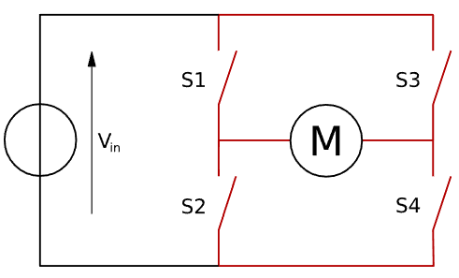

Optical Isolator is an electronic component that transfers electric signals between two isolated circuits using light rays. The circuit is closed even though there is no physical connection between both sides of the opto-isolator. It is particularly useful in safety purposes as due to the lack of physical contact, it protects certain parts of the circuit from overflow of current. It only allows the flow of current in one direction only.

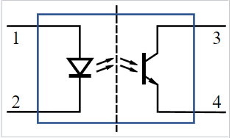

The L293D is designed to provide bidirectional drive currents of up to 600 mA (per channel) at voltages from 4.5 V to 36 V. It is used as an H-bridge in the circuit. The L293D is most often used to drive motors, but can also be used to drive any inductive load such as a relay solenoid or large switching power transistor. The L293D IC has a total of 16 pins that connect it to the outside world.

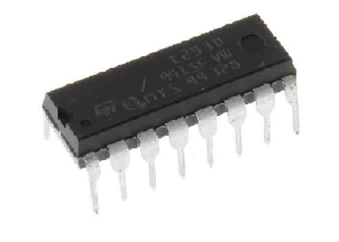

**4N25 OPTOCOUPLER IC** has two components integrated in it. One is INFRARED DIODE and another of INFRARED PHOTOTRANSISTOR. The IR DIODE is connected between terminals 1 and 2, the PHOTOTRANSISTOR is connected at terminals 4, 5 and 6.The internal setup of two components can be seen below. The IR radiation emitted by IR LED will not be visible outside the chip.

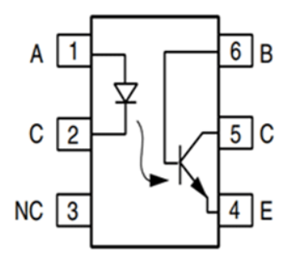

The circuit has been made by making the schematic diagram first. It was made in OrCad software and made use of PSpice simulations to get an idea of its working and verifying the connections

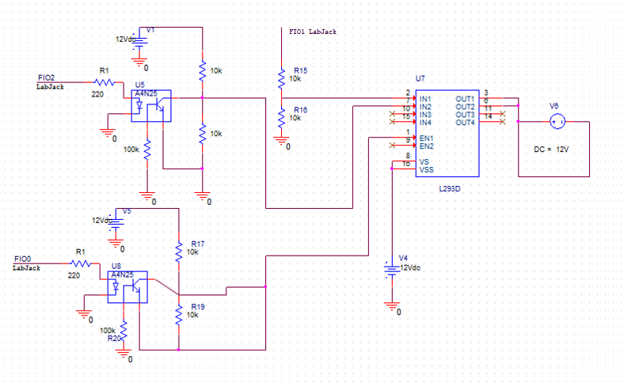

Some other components used in the circuit were various resistors for various purposes.

Making the project also made use of several non-technical skills of the group members as well. These included being available for meetings – online and offline – and participating actively. Motivating each other and helping with tasks wherever possible without meddling in their way.

There were numerous challenges to overcome as well. The biggest one being scheduling the meetings in a way that was easy to attend for all the members. Secondly, having limited time with the instruments and the power supply in the campus lab meant that the circuit could only be tested a few times before finalizing.

But all these problems were overcome by team work and communication.

# RESULTS AND DISCUSSIONS

We were able to develop the hardware portion of the circuit. The circuit was able to 4N25 the speed and direction of the motor. The L293D IC chip is used as an H-bridge to drive the motor. The motor is connected to pins 3 and 6 of the L293d IC chip. Pin 1 is connected to two 10kΩ resistors. One of the resistors is connected to the 12V source and the other resistor is connected to 12V ground. Pins 2 and 7 are connected to pins 5 of both 4N25 optical isolators. Pins 4 and 5 are connected to the 12V ground. Pins 8 and 16 go to the 12V source to supply power to the L293D IC chip. For the 4N25 optical isolators, Pin 1 connects to an FIO port of the UE9 LabJack to control the direction of the motor. Pin 2 connects to the ground of the UE9 LabJack. Pin 4 connects to the 12V ground. Pin 5 connects to two 10kΩ resistors, one connected to the 12V source and the other connected to the 12V ground. To control the speed of the motor, connect the FIO port to pin 1 of the L293D IC chip. In Spyder, the line myUE9.timerCounter(TimerClockBase=1, TimerClockDivisor=4, Timer0Mode=0, NumTimersEnabled=1, UpdateConfig=1, Timer0Value=30000) controls the PWM. TimerClockBase is set to 1 for 48MHz. The Timer0Mode is set to 0 for 16-bit resolution. Usually the TimerClockDivisor is set to 1, however if it were set to 1 it would give a frequency that is three and a half times required to change the speed of the motor. The TimerClockDivisor is set to 4 so that the frequency is around 200Hz. Controlling the duty cycle requires modifying the Timer0Value from 0-65536. To control the direction of the motor, the fio_state must be modified. When one FIO port is high and one FIO port is low, the motor will spin in one direction and vice versa.

## Extensions

If there was an extension for the project, there would be more time to be able to make an emergency stop switch button to immediately stop the motor. We would also have our PCB circuit created. Due to the wait time of creating a PCB, we were unable to have one made on time.

# CONCLUSION

In conclusion, the circuit is designed to interact with the LabJack UE9 to control the direction and speed of the motor. Multiple components used throughout the course of ETD555 have been utilized in the circuit. The main components which are the 4N25 optical isolator and the L293D IC chip are used to drive the motor in the circuit. The circuit interacts with python code in Spyder to control the speed of the motor using pulse width modulation and the direction of the motor by modifying the state of the FIO ports.